WEEK 1

MONDAY | TUESDAY | WEDNESDAY | THURSDAY | FRIDAY
AM  Crackers & Butter  Fruit  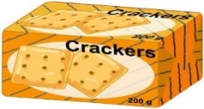  This Photo by Unknown Author is licensed under CC BY-ND | AM  Toast & Butter/Jam  Fruit  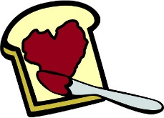  This Photo by Unknown Author is licensed under CC BY-SA | AM  Pizza Wraps  Fruit  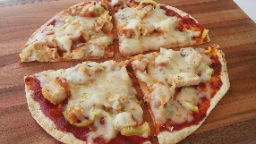 | AM  Bagels  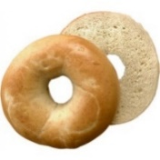  Fruit | AM  Baker’s Choice / Biscuits  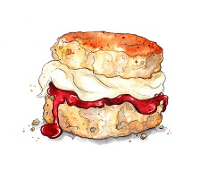  Fruit
PM  Fruit, veg & cheese  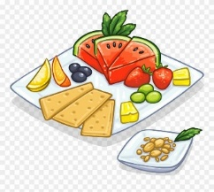 | PM  Fruit, veg & cheese | PM  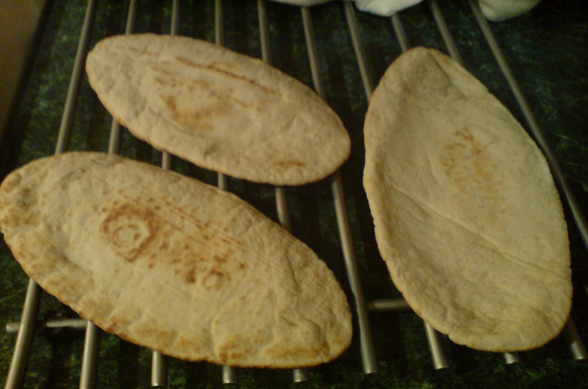  Fruit, veg & cheese  This Photo by Unknown Author is licensed under CC BY-SA-NC | PM  Fruit, veg & cheese | PM  Fruit, veg & cheese

WEEK 2

MONDAY | TUESDAY | WEDNESDAY | THURSDAY | FRIDAY
AM  Toast & Butter/Jam  Fruit  This Photo by Unknown Author is licensed under CC BY-SA | AM  This Photo by Unknown Author is licensed under CC BY-SA  Cornflakes  Fruit  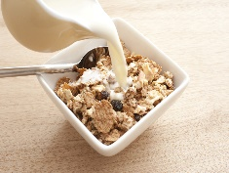  This Photo by Unknown Author is licensed under CC BY | AM  Make your own sandwich  Fruit  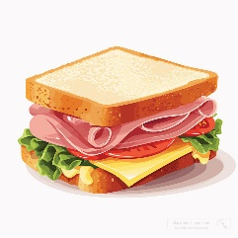 | AM  Scones  Fruit | AM  Porridge  Fruit  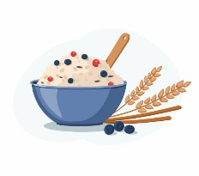
PM  Fruit, veg & cheese | PM  Fruit, veg & cheese | PM  Fruit, veg & cheese | PM  Fruit, veg & cheese | PM  Fruit, veg & cheese

